NAME : MAKVANA NEEL

ROLL NO : CE064

ID : 20CEUOS086

BATCH : A4

LAB06:

Code test:1

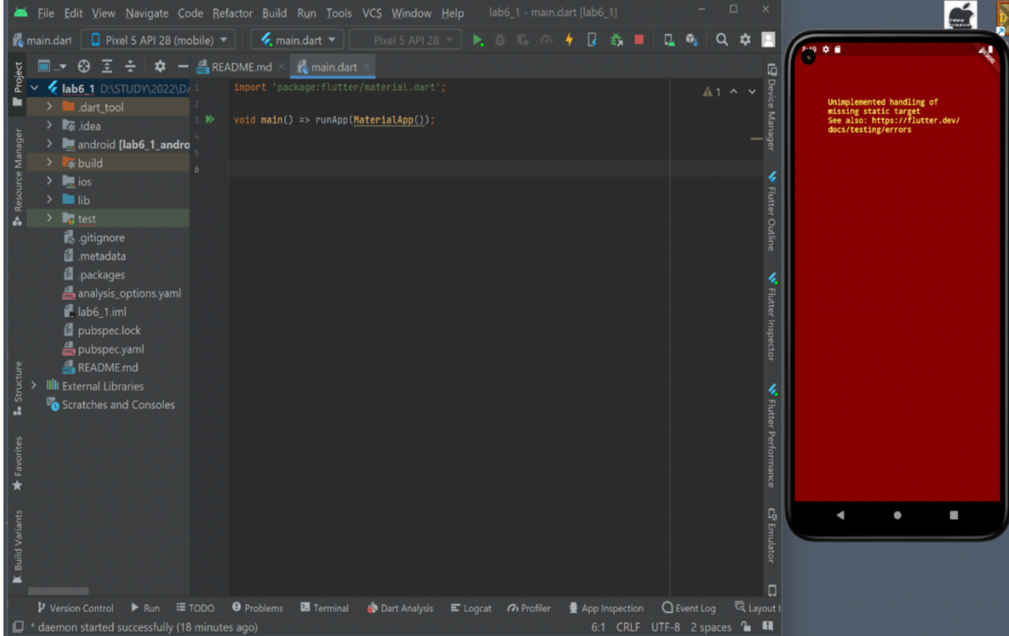

code test:2

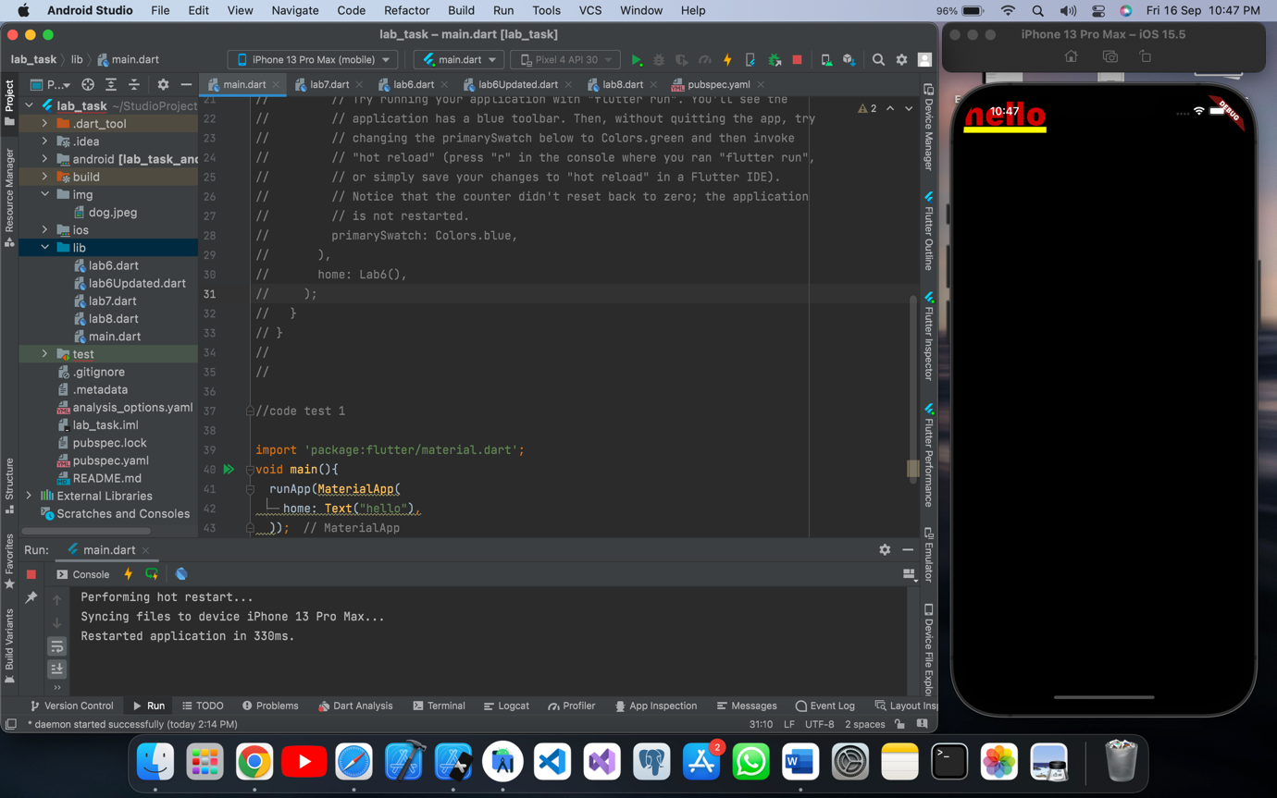

Code test: 3

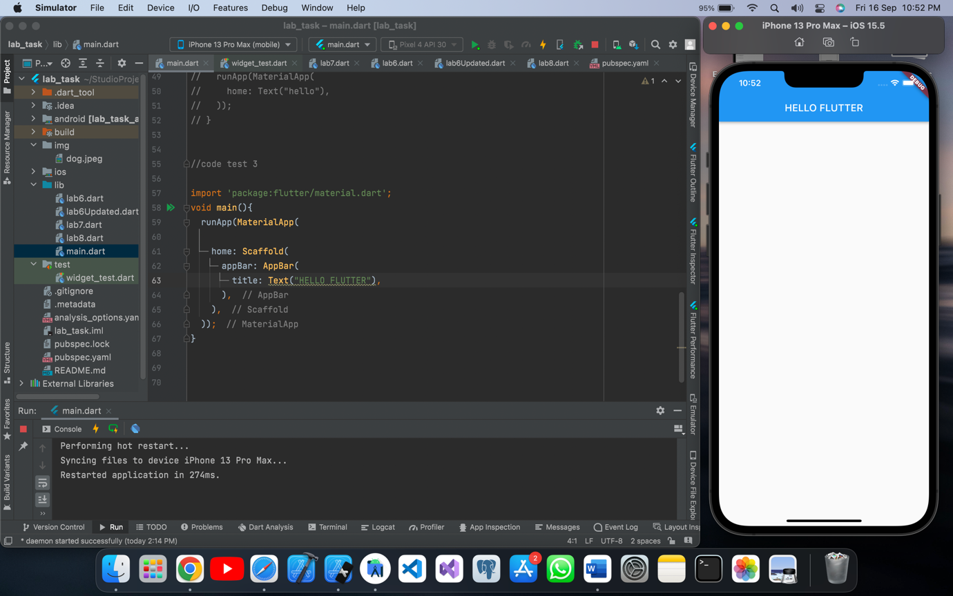

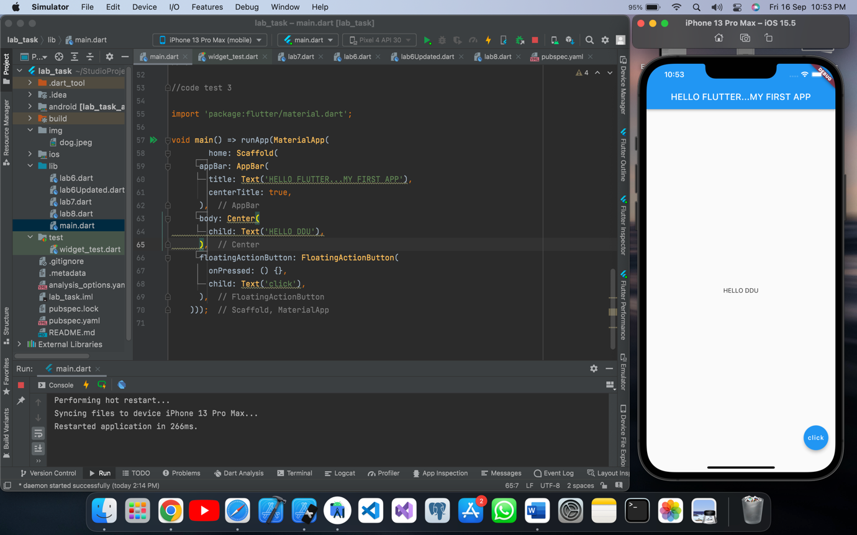

Code test 4:

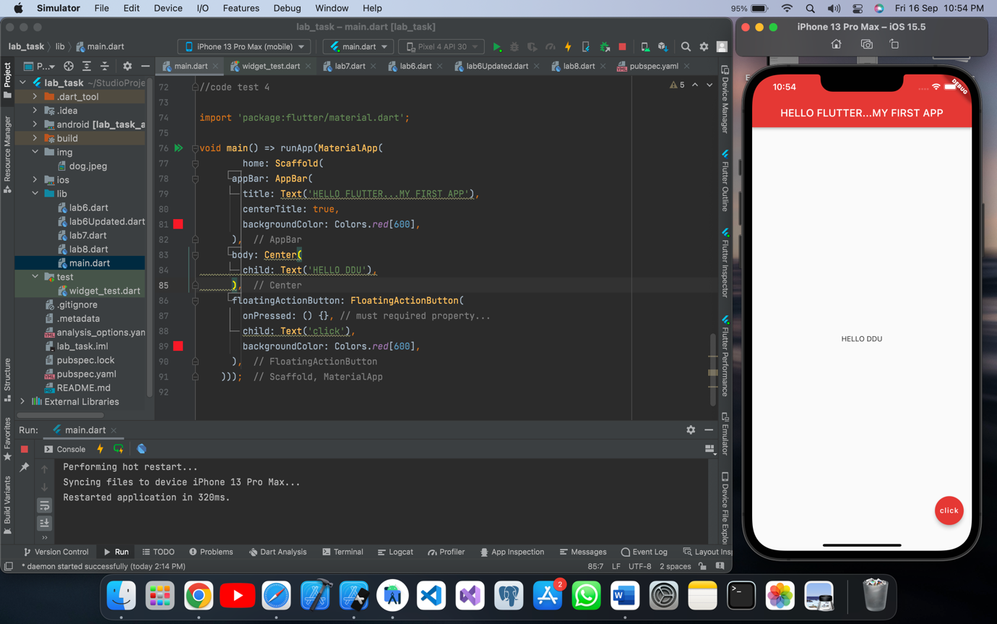

Code test 5:

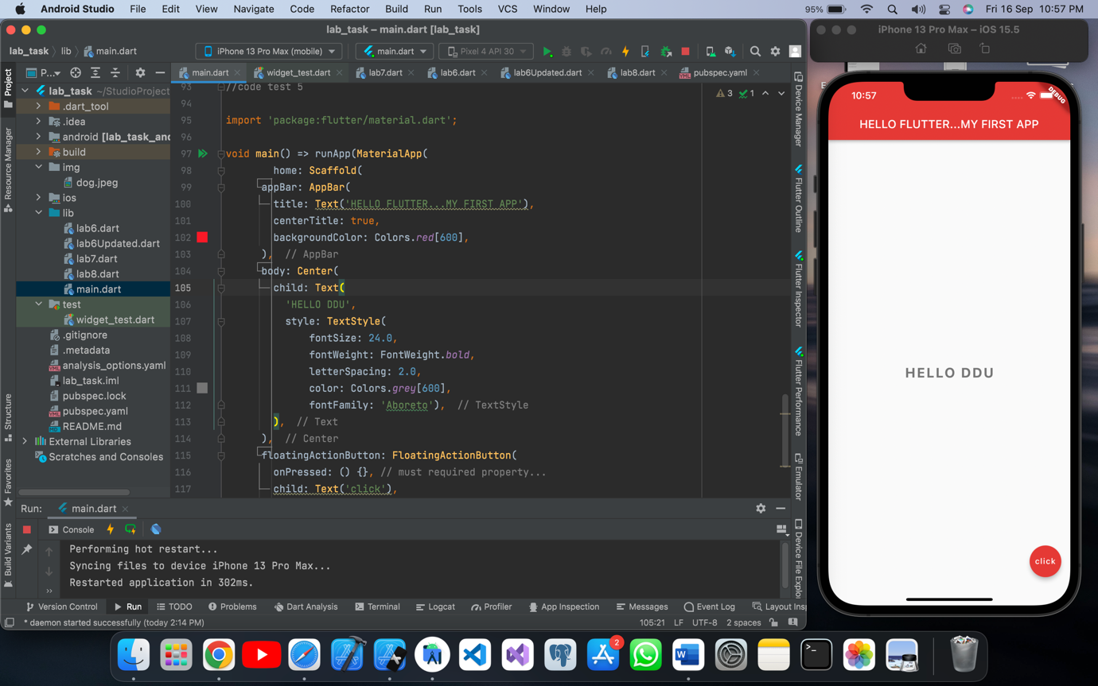

Code test 6:

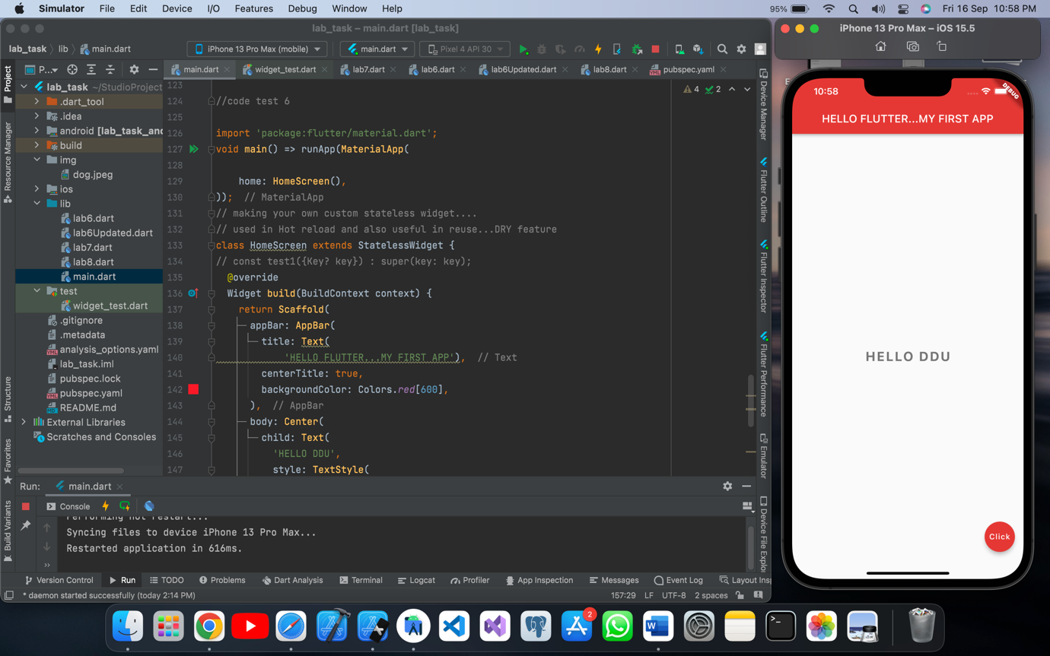

Final code of lab 6:

//code test 1  
  
// import 'package:flutter/material.dart';  
// void main(){  
// runApp(MaterialApp());  
// }  
  
//code test 2  
  
// import 'package:flutter/material.dart';  
// void main(){  
// runApp(MaterialApp(  
// home: Text("hello"),  
// ));  
// }  
  
//code test 3  
  
// import 'package:flutter/material.dart';  
//  
// void main() => runApp(MaterialApp(  
// home: Scaffold(  
// appBar: AppBar(  
// title: Text('HELLO FLUTTER...MY FIRST APP'),  
// centerTitle: true,  
// ),  
// body: Center(  
// child: Text('HELLO DDU'),  
// ),  
// floatingActionButton: FloatingActionButton(  
// onPressed: () {},  
// child: Text('click'),  
// ),  
// )));  
  
//code test 4  
  
// import 'package:flutter/material.dart';  
//  
// void main() => runApp(MaterialApp(  
// home: Scaffold(  
// appBar: AppBar(  
// title: Text('HELLO FLUTTER...MY FIRST APP'),  
// centerTitle: true,  
// backgroundColor: Colors.red[600],  
// ),  
// body: Center(  
// child: Text('HELLO DDU'),  
// ),  
// floatingActionButton: FloatingActionButton(  
// onPressed: () {}, // must required property...  
// child: Text('click'),  
// backgroundColor: Colors.red[600],  
// ),  
// )));  
  
//code test 5  
  
// import 'package:flutter/material.dart';  
//  
// void main() => runApp(MaterialApp(  
// home: Scaffold(  
// appBar: AppBar(  
// title: Text('HELLO FLUTTER...MY FIRST APP'),  
// centerTitle: true,  
// backgroundColor: Colors.red[600],  
// ),  
// body: Center(  
// child: Text(  
// 'HELLO DDU',  
// style: TextStyle(  
// fontSize: 24.0,  
// fontWeight: FontWeight.bold,  
// letterSpacing: 2.0,  
// color: Colors.grey[600],  
// fontFamily: 'Aboreto'),  
// ),  
// ),  
// floatingActionButton: FloatingActionButton(  
// onPressed: () {}, // must required property...  
// child: Text('click'),  
// backgroundColor: Colors.red[600],  
// ),  
// )));  
  
  
  
//code test 6  
  
import 'package:flutter/material.dart';  
void main() => runApp(MaterialApp(  
  
 home: HomeScreen(),  
));  
// making your own custom stateless widget....  
// used in Hot reload and also useful in reuse...DRY feature  
class HomeScreen extends StatelessWidget {  
// const test1({Key? key}) : super(key: key);  
 @override  
 Widget build(BuildContext context) {  
 return Scaffold(  
 appBar: AppBar(  
 title: Text(  
 'HELLO FLUTTER...MY FIRST APP'),  
 centerTitle: true,  
 backgroundColor: Colors.*red*[600],  
 ),  
 body: Center(  
 child: Text(  
 'HELLO DDU',  
 style: TextStyle(  
 fontSize: 24.0,  
 fontWeight: FontWeight.*bold*,  
 letterSpacing: 2.0,  
 color: Colors.*grey*[600],  
 fontFamily: 'Aboreto'  
 ),  
 ),  
 ),  
 floatingActionButton: FloatingActionButton(  
 onPressed: () {},   
 child: Text('Click'),  
 backgroundColor: Colors.*red*[600],  
 ),  
 );  
 }  
}